# Design of a Wearable and Portable Non-Invasive Ventilator (NIV)

| Team Members: | Suhail Anuar, Jimin Kwon, Mona Murphy, Yi Ling Soh, Vanessa Jade Tan |
| --- | --- |
| Supervisor: | Professor Kamran Behdinan (MIE), S. Ranjan Mishra (TA) |
| Client: | Dr. Osami Honjo (SickKids) |

## 

## Objective

To design a novel portable non-invasive ventilator (NIV) which aims to improve Fontan circulation. It should perform the main functions of a NIV, while achieving portability and adhering to physiological, technological, and regulatory limitations. Portability of the device is measured through its overall dimensions and weight, user mobility level and battery life. Effectiveness is measured through operating I:E ratio and min/max pressure range. Other objectives include a positive user experience, durability, and cost of the device.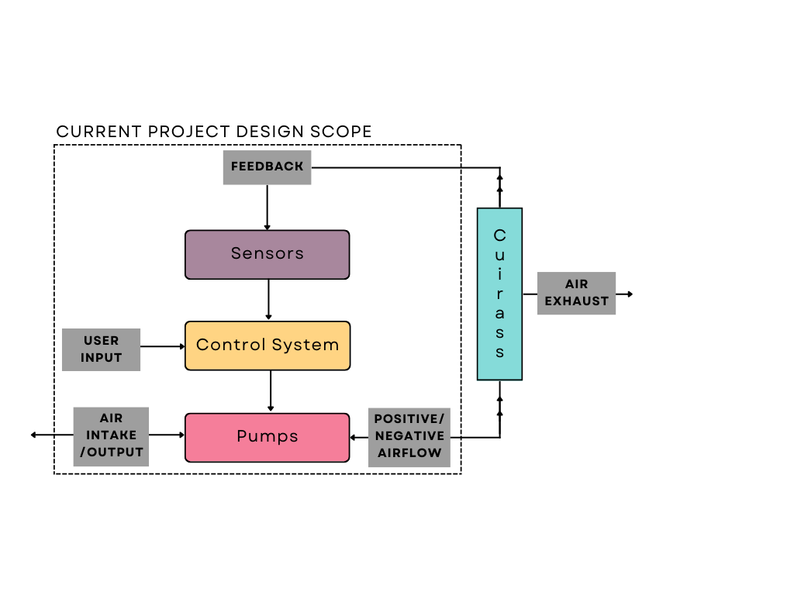

Engineering Design Process

The system is divided into subsystems of the pressure circuit, control system, and the jacket. Pressure circuit includes units that generate the negative and positive pressure within the volume in front of the wearer's chest, which is captured by the rigid shell of the jacket, also called the cuirass. The pressure circuit is controlled via the control system through parameters similar to that of existing ventilators, such as the I:E ratio, breathing rate, and desired pressure levels.

## Prototyping

The current prototype focuses on actualizing the pressure circuit and the control system. Components of the system are enclosed within the 3D printed casing measuring 20x32x11cm. The pressure circuit comprises diaphragm pumps and solenoid valves that pressurize and/or vacuum the air inside a plastic box that is used to mimic the cuirass. Arduino Mega is used to control the pressure circuit based on user input and feedback from the pressure sensor installed within the cuirass. Additionally, a digital pressure gauge is connected to the box for monitoring and validation purposes.

There are two modes of operation under development, constant negative pressure ventilation (NPV) and biphasic pressure ventilation (BPV).

## 

## Next steps

1. Integrate jacket and cuirass design with pressure and control system
2. More rigorous testing to ensure compliance with all standards and design validation
3. Development of a working prototype using medical grade materials
4. Development of Minimum Viable Product for further testing and improvements